Jennifer Daniel

CIT480

Chapter 6 Exercises

**Exercise 6-1:**

6-1 Part 1:

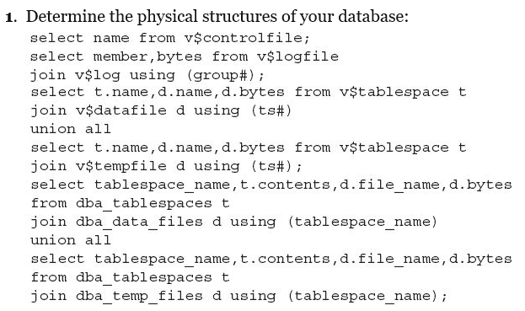

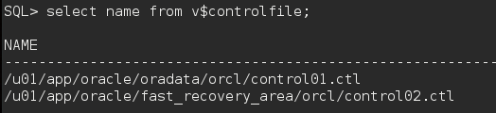

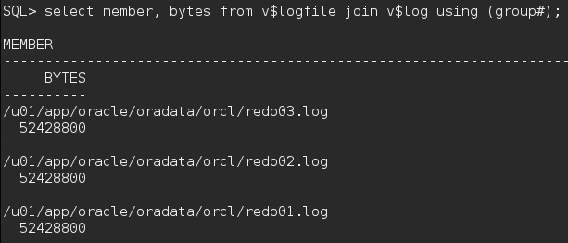

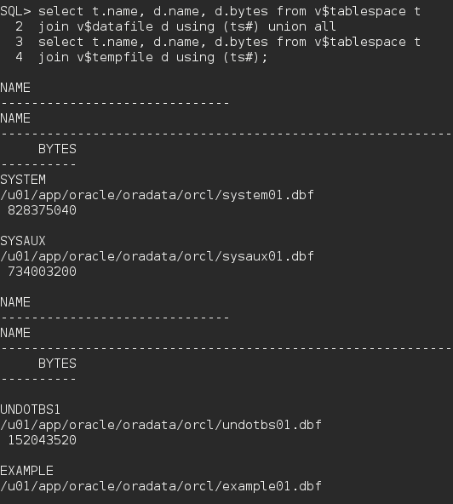

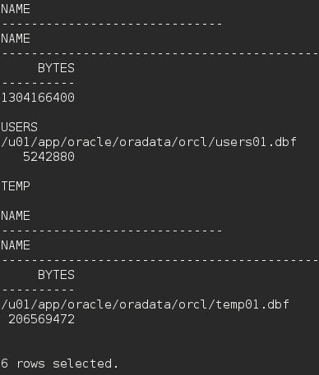

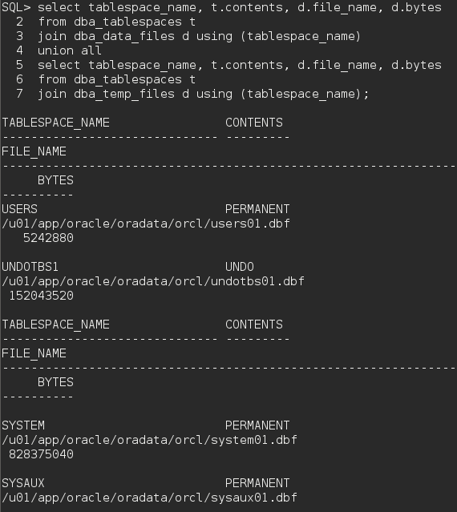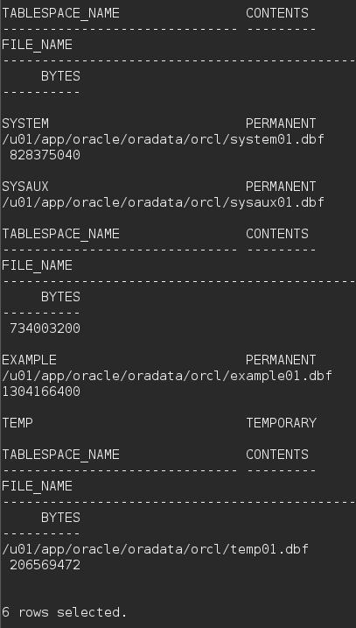

6-1 Part 2:



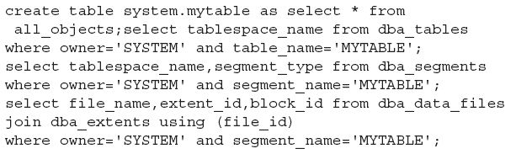



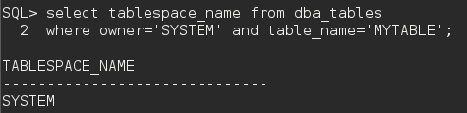

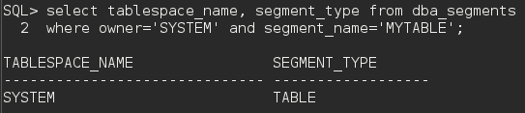

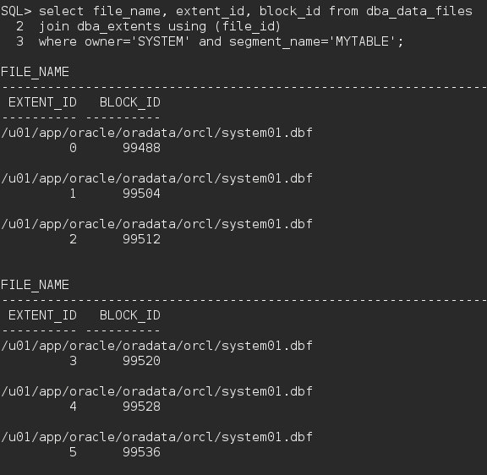

…

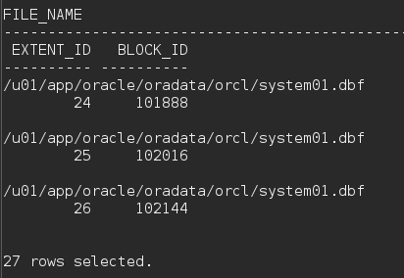

6-1 Part 3:

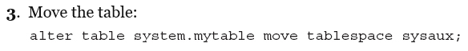

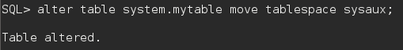

6-1 Part 4:

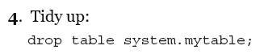



**Exercise 6-2:**

6-2 Part 1/2:

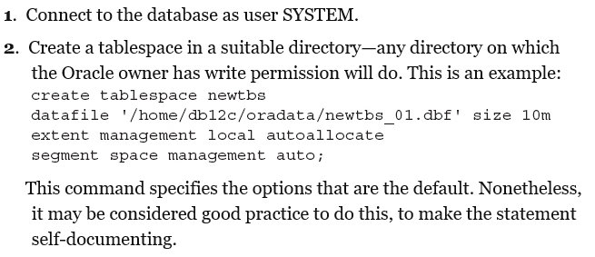

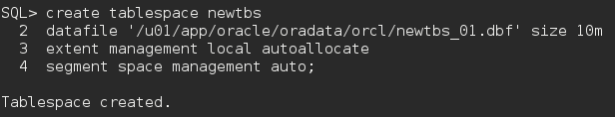

6-2 Part 3:

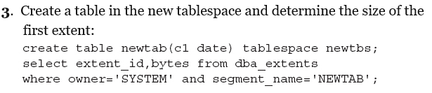

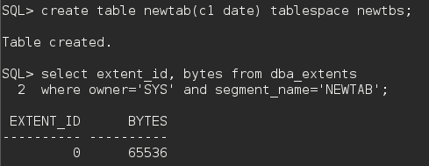

6-2 Part 4:

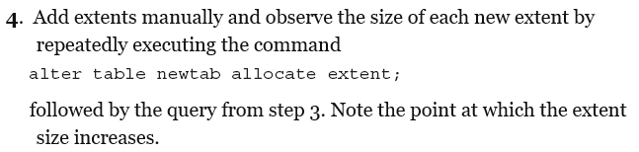

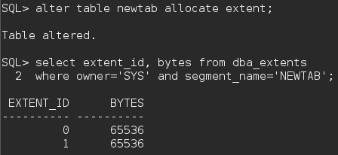

6-2 Part 5:

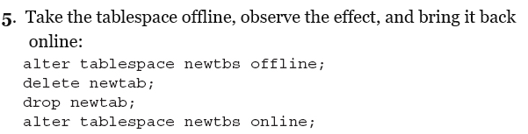

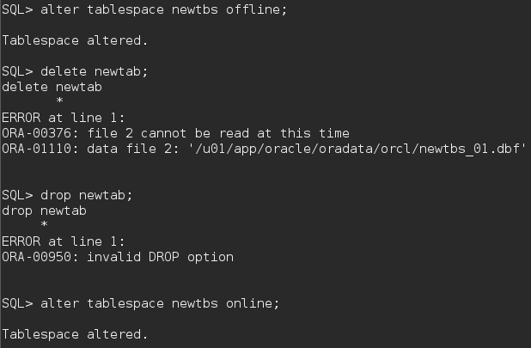

6-2 Part 6:

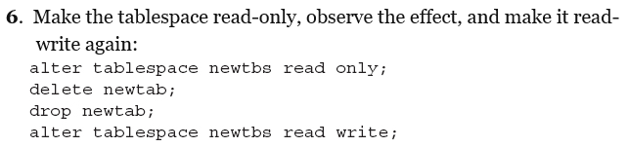

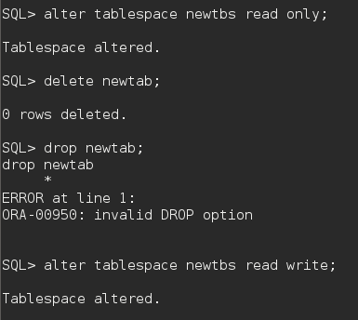

6-2 Part 7:

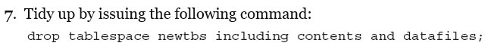

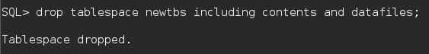

**Exercise 6-3:**

6-3 Part 1:

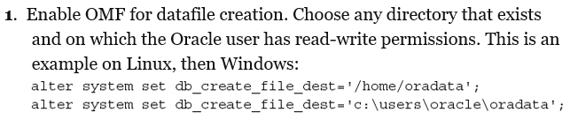



6-3 Part 2:





6-3 Part 3:

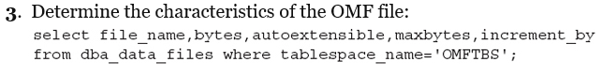

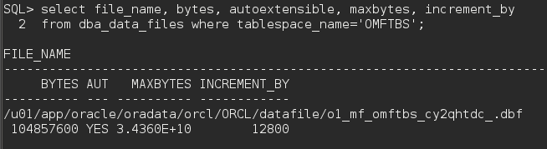

6-2 Part 4:

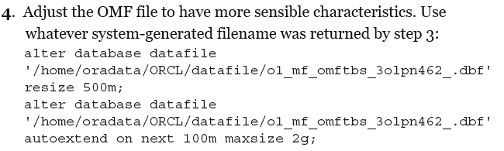

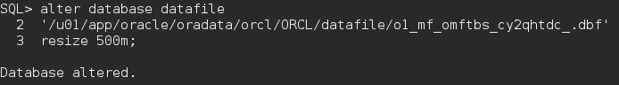

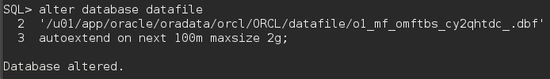

6-3 Part 5/6:

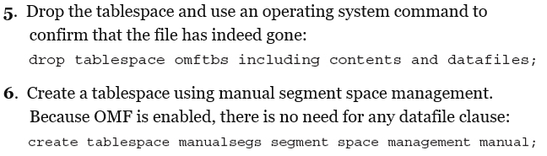



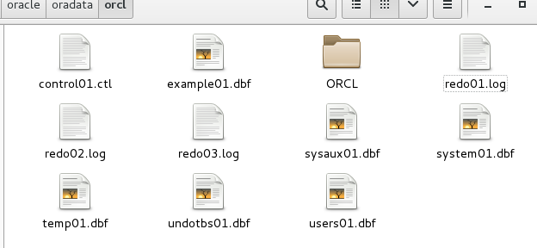

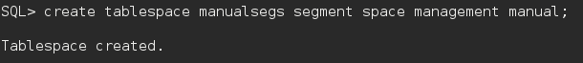

6-3 Part 7:

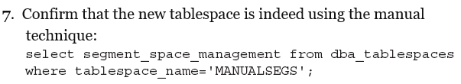

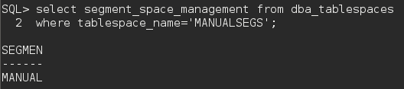

6-3 Part 8/9:

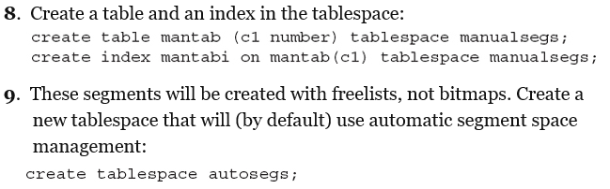

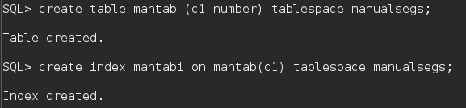

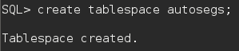

6-3 Part 10:

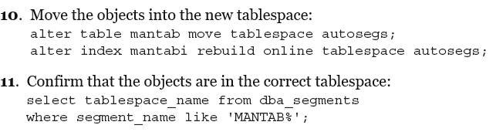

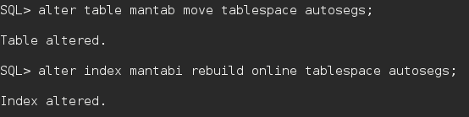

6-3 Part 11:



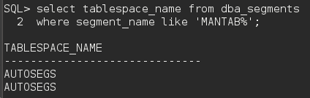

6-3 Part 12:



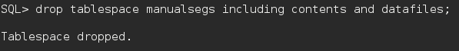

6-3 Part 13:

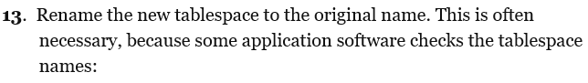



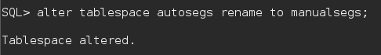

6-3 Part 14:

